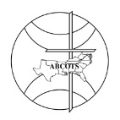
THE AMERICAN BAPTIST CHURCHES OF THE SOUTH
EXHIBITOR FORM
54TH Annual Session
Tuesday, Wednesday, Thursday
APRIL 29 – MAY 2, 2024

Theme: Shout It Again!

NAME/ORGANIZATION:

CONTACT PERSON:

ADDRESS:

PHONE NUMBER:

EMAIL ADDRESS:

Complete form and return with payment to the ABCOTS office at PO Box 47277, Windsor Mill, MD 21244-0277.

Forms may be emailed to abcotsadmin@abcots.org, space is not guaranteed until payment has been received in the ABCOTS office.

The vendor fee is $250.00 for a 6’ table with two chairs.

