NEW SOUTHERN ROCK BAPTIST CHURCH
750 Buchanan Street, NW • Washington, DC 20011 • (202) 723-2288 • www.nsrbc.org

Senior Pastor Vacancy Announcement
Opening Date: May 1, 2026 Closing Date: June 30, 2026
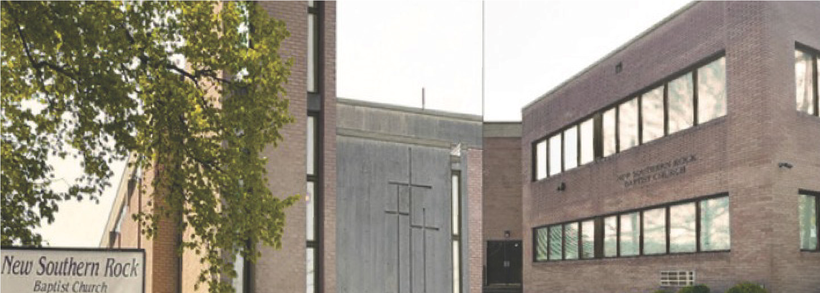
Our Mission - To Win others to Christ following the ministry of Jesus Christ adhering to the Great Commission: Matthew 28:19
Our Vision: - To Love A People (John 3:16); Teach A People (Hosea 4:6); Make A Holy People (1 Peter 1:16)
New Southern Rock Baptist Church (NSRBC) was organized in 1954 under the leadership of the late Reverend H. C. Mack. NSRBC is an active member of the Progressive National Baptist Convention, the Baptist District of Columbia & Vicinity Convention, and the Mount Bethel Educational Congress.
New Southern Rock is currently seeking a God-fearing servant-leader whom God is preparing to serve as our next Pastor. The ideal candidate must have a strong passion for Christ, a thorough understanding of the Bible and a commitment to Baptist doctrine. We are prayerfully confident that the Lord will lead us to the right individual, and that He will also lead that individual to us.

Duties & Responsibilities
Lead worship services, Sunday school, Bible study, prayer services, and deliver Bible based sermons rooted in biblical truth. Conduct Baptism and Holy Communion.
Officiate at weddings, funerals, memorial services, and any other spiritual services in accordance with church By-Laws.
Lead with vision, empowering both layperson and ministry leaders to fulfill the mission and operation of the church.
Demonstrate administrative competency and stewardship of church operations and finances.
Ability to resolve conflicts and lead diverse multigenerational congregants.
Preside over all business meetings of the church.
Qualifications & Experiences
Must be a licensed and ordained Baptist minister in accordance with the Baptist doctrine, with a minimum of 5 years of ordained ministry experience.
A minimum of a bachelor’s degree; a Master of Divinity or equivalent theological degree from an accredited seminary is strongly preferred.
Efficient in using technology to expand the ministries and enhance the administration of church operations.
Experience in growing a church and moving forward in faith and purpose.
Strong interpersonal and communication skills.
Demonstrate spiritual maturity, integrity, and humility in both personal and private life. Technologically adaptable and open to innovation in ministry and outreach using social media.
Committed to community outreach, actively supporting initiatives, and building partnerships that impact the greater community.
How To Apply
All interested persons must submit an initial candidate packet consisting of the following documents:
Cover Letter (300 words or less expressing your reason for applying for the position) Current Résumé
Copies of degree(s), ministerial license and ordination certificate
Two sermons preached within the past 6 months. Please provide a link to access sermons (YouTube, Facebook, or the Church Website).
Provide four references (two clergy and two layperson) with contact information to include their email address and phone number.
The Pastoral Search Committee will acknowledge receipt of all submitted packets. To be considered, all application packets must be received on or before June 30, 2026. Only one submission will be accepted per applicant. Incomplete packages will not be considered. Once submitted, all copies of application materials become the property of the Pastoral Search Committee and will not be returned. All information submitted will be treated as confidential. Additional information may be requested or required.
Final candidates must consent to a full-disclosure personal background investigation, including criminal history, drug screening, credit and financial history review, educational credentials, and military discharge, if applicable. All applications will be deleted at the end of the process.
If you have additional questions, you may contact Deaconess Claudette Randall-Mills by email at pastor_search@nsrbc.org.
Application Deadline: June 30, 2026
Click here to apply: NSRBC Senior Pastor Application

